Section 5.2: Built Heritage

Built Heritage

1. The long history of the parish means that it has a rich and diverse built heritage, with a variety of buildings of differing styles and designs, many of high quality.

2. The history of the parish and how this has shaped its development has been well researched and documented in books and other publications, including the Kirkby Malzeard Village Design Statement. There are several active local history groups, such as The Discover Dallowgill History Project website and the Kirkby Malzeard, Laverton and Dallowgill History Facebook Group.

3. The community is proud of the parish’s rich history and heritage. It is important to its distinctive character and a strong sense of identity. The residents wish to see that future development protects, conserves, and where possible, enhances the historic environment. This was a major theme of the consultation undertaken as part of the development of the Plan.

4. It is recognised that some change is inevitable and, indeed, necessary to address some of the economic, environmental and social issues highlighted in the Plan. However, they would like to see this change managed, so that any development is well designed and sympathetic to the local character and history. The design of new development should add to the distinctive character and charm of the parish and generally what makes it special and loved.

Buildings of National Heritage Importance

5. Many buildings and other structures in the parish have been recognised as being of national importance. About 30 have been granted ‘Listed Building’ status by the Government. A Listed Building is one that has been placed on the Statutory List of Buildings of Special Architectural or Historic Interest.

6. In addition, there are two scheduled Ancient Monuments; the site of a Motte and Bailey Castle at Mowbray Castle and the site of ancient earthworks on the Carlesmoor edge of Kirkby Malzeard moor. An Ancient Monument is an early historical structure or monument that has been designated by the Government as worthy of preservation.

7. The full list of buildings and structures that have been designated as national importance (Historic England, 2021) is shown below. This includes a range of different architectural styles and types of buildings, including a dovecote, dwellings, farm buildings, public house, Table Tomb and the Twelfth Century Grade I St Andrews Church. The location of Listed Buildings in the Plan Area can be viewed by using this link and selecting the Listed buildings layer - Listed Buildings

Statutory Listed Heritage Assets in the Parish (2022)
Name of Asset | Location | Grade
Listed Buildings
Table tomb approximately 3 metres to south east of Chancel of Church of St Andrew | Approximately 3 metres to south east of chancel of Church of St Andrew, Church Street, Kirkby Malzeard | II
Cottage to right of Churchbye House | Right of Churchbye House, Church Street, Kirkby Malzeard | II
Churchbye House and Attached Railings | Church Street, Kirkby Malzeard | II
Market Cross | Main Street, Kirkby Malzeard | II
Rose Cottage and The Cottage | Main Street, Kirkby Malzeard | II
South View | Main Street, Kirkby Malzeard | II
Dovecote at Kexmoor Farm East | Ringbeck Road, Kirkby Malzeard | II
Mowbray House | Kirkby Road, Kirkby Malzeard | II
Tombstone to Peter Save | Approximately 2 metres to south of West End of nave of Church of St Andrew, Church Street, Kirkby Malzeard | II
Table Tomb to George Hewitt | Approximately 5 metres to south east of chancel of Church of St Andrew, Church Street, Kirkby Malzeard | II
Church of St Andrew | Church Street, Kirkby Malzeard | I
Table Tomb to William and Helen Holds | 3 metres to south of chancel of Church of St Andrew, Church Street, Kirkby Malzeard | II
Pinfold | Main Street, Kirkby Malzeard | II
Cart Shed/Granary to Kexmoor Farmhouse East | Ringbeck Road, Kirkby Malzeard | II
Creets Bridge | Ripon Road, Kirkby Malzeard | II
Medieval cross | Approximately 6 metres to south east of chancel of Church of St Andrew, Church Street, Kirkby Malzeard | II
The Old Rectory | The Old Rectory, Church Street, Kirkby Malzeard | II
The Shoulder of Mutton | Church Street, Kirkby Malzeard | II
1, Church Street | 1 Church Street, Kirkby Malzeard | II
Barkways And Greystone | Kirkby Road, Kirkby Malzeard | II
Kexmoor Farmhouse East and Attached Outbuilding and Pump | Ringbeck Road, Kirkby Malzeard | II
Lawnwith Farmhouse | Ripon Road, Kirkby Malzeard | II
Barn at Junction with Long Swales Lane | Junction with Long Swales Lane, Main Street, Kirkby Malzeard | II
The Grange | Carlsmoor, Kirkby Malzeard | II
Bowes Farmhouse | Dallow, Grantley | II
Laverton Grange | Laverton | II
Azerley Grange | Pateley Bridge Road, Laverton | II
Scheduled Monuments
Motte and Bailey Castle, known as Mowbray Castle, | East of Kirkby Malzeard | Scheduled
Fortress Dyke Camp | Dallowgill Moor, Laverton | Scheduled

8. Generally, the condition of these buildings is good. No Listed Buildings, for example, are included on Historic England’s Heritage at Risk Register (2021).
9. The designation of these buildings and structures as a Listed Buildings and Ancient Monuments gives them special legal protection beyond that which can be provided through a neighbourhood plan. It is important, however, that the Plan highlights the important contribution they make to the distinct character and identity of the parish and the need to conserve and enhance this.

Non-Designated Heritage Assets

10. In addition to the above ‘statutory’ designated heritage assets, there are other buildings and structures that while they do not meet the criteria for formal designation, they still have local historic or architectural importance and warrant retention and conservation. These are often known as non-designated heritage assets.

11. The North Yorkshire Historic Environment Record (‘HER’) identifies over 400 heritage items within the parish. These include designated and non-designated local archaeological sites and finds, historic buildings and historic landscapes and a wide diverse range of items including historic buildings; remains of a post medieval sheepfold; the site where a late Iron Age or Roman Statue was found; a well and two World War 2 aircraft crash sites.

12. Neighbourhood plans may identify non-designated heritage assets for greater conservation through the planning system.

13. The Plan has taken the opportunity, using published guidance developed by the local planning authority to identify several buildings and structures within the parish that are important locally and meet the criterion to be non-designated heritage assets. These include buildings and structures identified as part of the HER as well as other assets considered locally significant.

14. To ensure that these assets are considered appropriately in planning proposals, the Plan formally identifies them as non-designated heritage assets.

15. This approach supports and accords with national and local planning policies. A good example is Policy HP2: Heritage Assets in the Local Plan which seeks to conserve heritage assets both designated and non-designated, stating, amongst other things, that ‘Proposals which would remove, harm or undermine the significance of a non-designated heritage asset will be permitted only where the benefits are considered sufficient to outweigh the harm’.

16. While their identification as such will not significantly change any of the planning controls affecting alteration or demolition, many buildings have permitted development rights that allow some minor building operations and, in some cases, demolition can be carried out without recourse to planning or other permissions. Where a planning application is needed, then its identification as a Kirkby Malzeard, Laverton and Dallowgill Parish Non-designated Heritage Asset will be a ‘material consideration’, i.e., the assets' local heritage significance will be taken into account when making a decision on the development proposals and such proposals will be assessed against Policy KMLD4 and other relevant local and national planning policies.

17. Further information regarding their heritage value is provided in the accompanying support document which can be found at Appendix A.

POLICY KMLD5: NON-DESIGNATED HERITAGE ASSETS
The Plan identifies the non-designated heritage assets listed below and illustrated at Appendix A.
- The Queens Head Public House, Kirkby Malzeard.
- The Ebenezer Methodist Chapel, Kirkby Malzeard.
- Greygarth Methodist Chapel and School Room, Dallowgill.
- The Mechanics Institute, Kirkby Malzeard.
- The Chapel of the Resurrection, Laverton.
- Laverton Bridge.
- Village Pump, Laverton
- Greygarth Monument, Dallowgill.
- St. Peters Church, Dallowgill.
- Dallowgill Bridge.
- Swetton Bridge.
- Stopes Bridge, Dallowgill.
- Aqueduct near Low Ray Carr, Dallowgill.
- Aqueduct across Carlesmoor Beck, Dallowgill.
- Sighting tower at Carlesmoor, Dallowgill.
- The Potato House, Carlesmoor.

Development must conserve these assets and their settings in a manner appropriate to their heritage significance.

Local Area of Special Character and Heritage

18. There is a cluster of nationally and locally recognised heritage buildings and structures to be found in and around Church Street, Kirkby Malzeard.
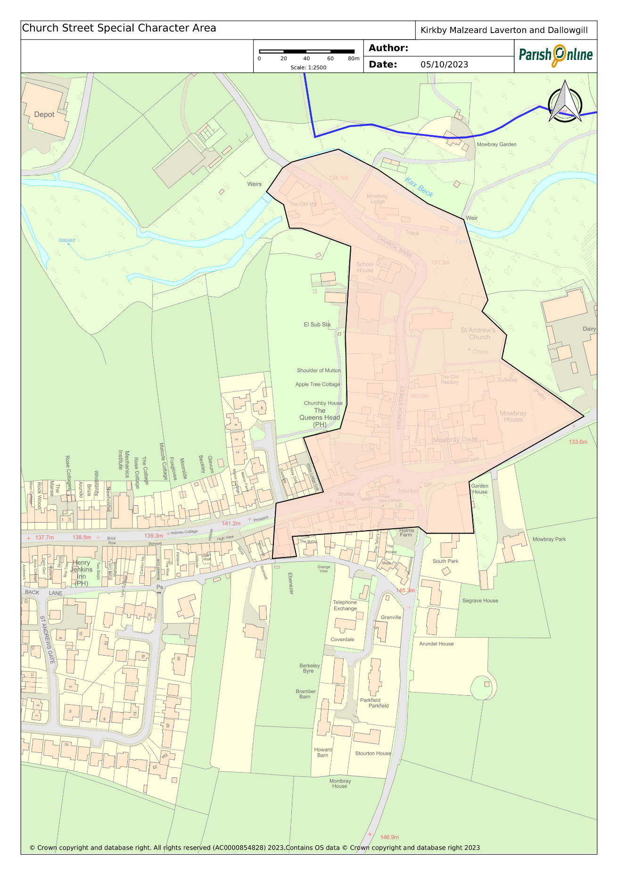

19. The Plan seeks to ensure that the distinctive character of the area is fully recognised and conserved in the planning system. A special character that is derived not only because of the historically and architecturally important buildings to be found within it but also its history, layout and open spaces.

20. To help ensure this, the Plan proposes that it be designated as a Local Area of Special Character and Heritage. This will then give it formal recognition in the planning system. Its identification as such does not introduce any specific planning restrictions or measures, for example, restricting permitted development rights. Permitted development rights allow certain changes to be made to a building without planning permission. However, developers would be required to show that development proposals respect and, where possible, enhance the character and qualities of the Local Area of Special Character and Heritage.

21. Ideally, the community would like to see it designated as a Conservation Area through this Plan. However, rules governing the preparation of neighbourhood plans mean that the Plan cannot designate it as such; only the Local Planning Authority can do this. Its designation as a Conservation Area will be explored with the Local Planning Authority in due course. In the meantime, the Plan will look to designate it as a Local Area of Special Character and Heritage to give it formal recognition and appreciation in the planning system.

POLICY KMLD6: CHURCH STREET KIRKBY MALZEARD LOCAL AREA OF SPECIAL CHARACTER AND HERITAGE
Within the Church Street, Kirkby Malzeard Local Area of Special Character and Heritage as proposed and shown on the Proposals Map and described in Appendix B, development proposals should be of high quality and designed to respect and enhance its distinctive character.

Ensuring Good Design

22. Paragraph 124 of the NPPF makes it clear that ‘good design is a key aspect of sustainable development, creates better places in which to live and work and helps make development acceptable to communities.’ The NPPF reinforces that design policies should be developed with local communities, so they reflect local aspirations and are grounded in an understanding and evaluation of each area’s defining characteristics. It sets out clearly at paragraph 125 that ‘Neighbourhood Plans can play an important part in identifying the special qualities of each area and explaining how this should be reflected in development.’

23. The community attaches high priority to achieving development that are sustainable, of high quality and respond positively to the distinctive character of the local area.

24. It was evident, for example, that 373 of the 412 (90%) of the respondents to the community survey felt that newly built properties must have adequate on-site parking with well over half also prioritising the use of traditional materials (71%), traditional design and construction (64%) and the use of landscaping and trees (71%).

25. Drawing on the earlier work in the 2002 Kirkby Malzeard Village Design Statement and on the views expressed during the consultation process, a general design policy to which all developments coming forward within the Parish must respond positively to has been developed. This has been developed in support of and should be read in conjunction with local and national planning policies that ensure high quality and distinctive design.

POLICY KMLD7: ENSURING HIGH QUALITY DESIGN.
Development proposals must achieve a high quality of design that respects and where possible enhances the distinctive character of the local area. Development proposals of poor or indifferent design which fail to take the opportunities available for enhancing the local character and sustainability will not be supported. Proposals should be designed in such a way as to meet the following criteria:
a) Reinforce the distinctive qualities of the environment in which it is located, taking account of natural and built character, historical context and established patterns of development.
b) Materials chosen should complement the design of the development and add to the quality or character of the surrounding environment. Elevations to new build properties should be faced with natural stone of the type typical of the area with the appearance of buildings to be inherently traditional.
c) Extensions to existing buildings should follow a design approach that is consistent and in keeping with the building in the use of materials, design and roofline.
d) Good use should be made of site characteristics and surroundings, including: layout and use; and form of space within the site; siting; scale; height; proportions and massing; orientation; architectural detailing; landscape, existing plants, trees and other features and materials;
e) Incorporate adequate landscaping, where practical, to mitigate the visual impact of the development and to ensure that proposals harmonise and merge into the existing rural, village and hamlet context and respond to the wider countryside setting.
f) Protect residential amenity, giving careful consideration to noise, privacy, outlook and to sunlight and daylight.
g) Ensure that the design of roads, parking areas and vehicular access includes adequate provision for road safety and measures to avoid indiscriminate parking by residents and visitors.
h) Positively contribute to mitigation of climate change and meeting climate change targets by:
i. incorporating high standards of energy efficiency and use of renewable energy.
ii. reducing lifecycle carbon emissions through design such as building layout and orientation, choice of materials and construction techniques.
iii. supporting the transition to low carbon or zero emissions forms of transport by measures such as installation of electric vehicle charging points in new dwellings, in public spaces, and in retail or commercial development (see also Policy KMLD15).

http://kirkbymalzeardarea.org.uk/MAP.aspx?pid=KMArea_en-GB&aid=nn_263844493_0
Search the List - Find listed buildings, monuments, battlefields and more | Historic England
https://historicengland.org.uk/advice/heritage-at-risk/search-register/
https://www.heritagegateway.org.uk/gateway/default.aspx
5https://www.northyorks.gov.uk/planning-and-conservation/heritage-conservation-areas-and-listed-buildings/heritage-conservation-areas-and-listed-buildings-harrogate/non-designated-heritage-assets

