Section 5.5: Infrastructure

Highway Safety

- Much of the current road network consists of rural country lanes, many narrow and winding. It is simply not designed for modern vehicular traffic. This is compounded by the significant amount of traffic, including large agricultural vehicles and heavy goods vehicles, that passes through the parish. As a consequence, congestion and highway safety is a serious and growing issue on many roads, not only for vehicle users but also vulnerable road users such as pedestrians, cyclists and horse riders. Walking, cycling and horse riding are all popular activities in the parish.

- Further new development and the continued growth in tourism in the parish and the surrounding areas will bring with it more vehicles, which could result in an increase in congestion and issues for road safety.

- Speeding is also an issue throughout the parish, but particularly along Main Street in Kirkby Malzeard. Roads generally are narrow with few natural or other obstacles to slow down motorists. Road signs do direct drivers to slow down and drive safely within the speed limits, but many fail to do so. When asked in the community survey ‘How important are these specific issues within our Neighbourhood Area?’ over 91% (358 out of 412) of respondents identified speeding in villages to be important or very important and 86% (337 out of 412) speeding in rural villages to be important or very important.

- Whilst the formulation of transport policy at a local level is primarily a matter for North Yorkshire Council as the Highway Authority, the Plan does support and encourage actions that can be taken to address highway safety in areas where road safety issues have been identified as a significant concern.

- Through the Plan’s development, several areas of Main Street in Kirkby Malzeard were identified where road safety issues have been highlighted on which action is required to remedy. These include the Market Cross junction, the section at the western end of Main Street near to the Ringbeck Road junction, the area adjacent to the Long Swales Lane junction and the area in front of the Mechanics Institute Village Hall.

- It was also considered essential that any new development is linked to the village centre by pavements.

POLICY KMLD13: PROMOTING HIGHWAY SAFETY
To be supported, development proposals must ensure highway safety.

PARISH ACTION 4: HIGHWAY SAFETY.
The Parish Council will work in partnership with the Highway Authority, the Local Planning Authority and other bodies to encourage opportunities to improve highway safety, particularly where the safety of vehicle and vulnerable users has been identified locally as a priority, including Main Street in Kirkby Malzeard.

Car Parking in Kirkby Malzeard

- On street car parking is a significant issue in Kirkby Malzeard. This was highlighted as a concern in the consultation.

- The roads and much of the housing in the village were not designed for the needs of modern traffic. The roads and pavements tend to be narrow, and much of the older parts of the village were designed with no off-street parking. Indeed, in most of the village on-street parking is the only means of parking especially along Main Street. Consequently, there is a serious issue with on-street parking, which has a detrimental effect on pedestrian and road safety and the ease by which pedestrians and vehicles can travel safely within the village.

- It is, therefore, important that any development does not adversely impact car parking provision in the village and wherever possible improves it.

POLICY KMLD14: CAR PARKING IN KIRKBY MALZEARD.
To be supported, development proposals in Kirkby Malzeard should incorporate sufficient, safe and convenient car parking provision in accordance with the most up to date highway standards.
Development proposals that result in the loss of car parking provision in Kirkby Malzeard will only be supported where:
a) it can be shown that the loss of parking will not have a severe adverse effect on parking provision and road and safety in the nearby area; or
b) adequate and convenient replacement car parking provision can be provided.

- During the preparation of this Plan, several specific suggestions were made about other actions that could be taken forward to do improve parking situation in Kirkby Malzeard. One idea is to establish a community car park on part of ‘The Green’. This site, owned by the North Yorkshire Council is considered to be suitable for this use as it would serve the nearby Highside Playing Field, where serious parking problems arise, particularly when sporting activities take place, and also the Doctors Surgery. Furthermore, it would provide additional parking for residents of The Green when not otherwise in use. This idea is to be taken forward by the Parish Council and the wider community.

PARISH ACTION 5: PROVISION OF PUBLIC CAR PARK IN KIRKBY MALZEARD.
The Parish Council will work in partnership with the Highway Authority, Local Planning Authority and other interested bodies and individuals to explore the feasibility of developing part of ‘The Green’, off Main Street, Kirkby Malzeard to provide a public car park as illustrated by the map above. The provision of publicly accessible charging points for ULEVs will also be considered.

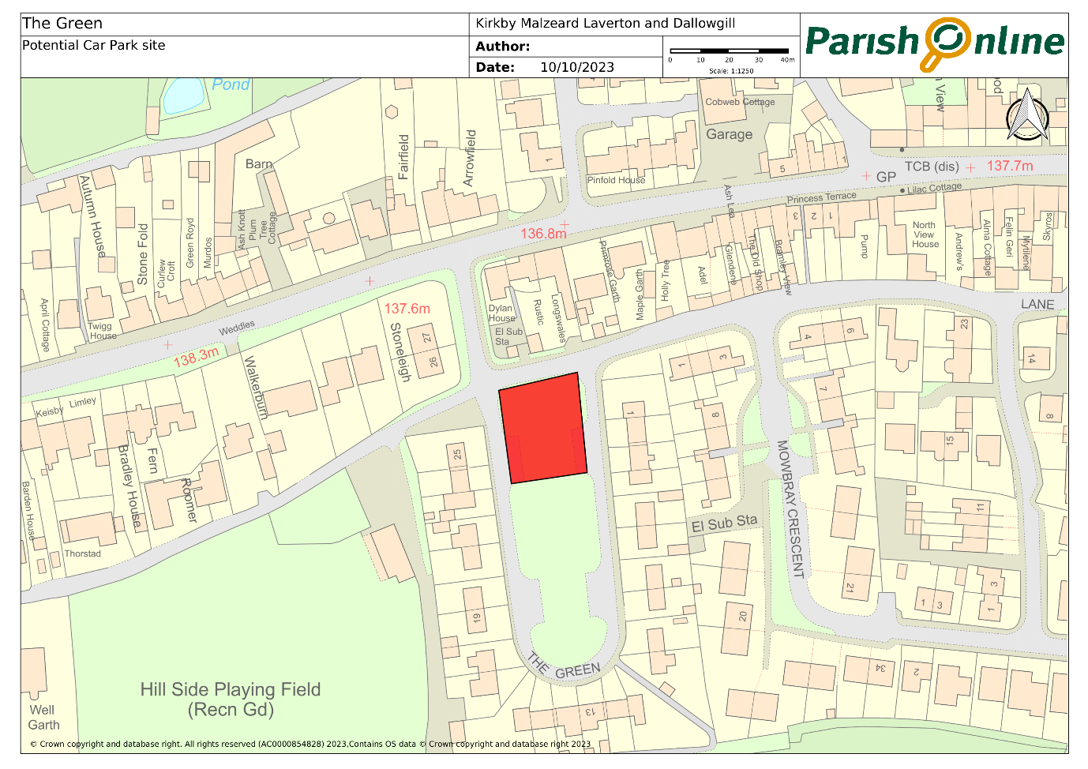

Public Transport

11. Public transport within the Plan Area is very limited in nature, as in most rural areas, comprising a bus service only, with the nearest connections to the national rail network being at Thirsk (13 miles distant) and Harrogate (14 miles distant).
12. At the time of the initial public consultation the only bus service available in Kirkby Malzeard was that provided by Dales and District service number 138 (Mondays, Thursdays and Saturdays - one journey a day leaving at 09.15am and returning at 12.52pm) and 138a (Monday to Friday – one journey a day leaving at 07.08am and returning at 18.22pm).
13. We asked within that consultation how frequently people used the service and what could be done to make them use it more regularly. Of the 403 people who answered whether they used it 387 said that they ‘never’ or ‘rarely’ used it, leaving only 15 respondents using it on a regular basis.
14. In order to attempt to establish what might make people use it more frequently 199 stated that an increased frequency of service, 91 said a community bus/taxi would help and 64 indicated that a rescheduled service would make a difference. Other constructive comments included making the school bus available for other users and cheaper fares. Clearly, as is the picture nationally, the vast majority of residents and employees use cars to travel in and around the area because the other options are impractical for them.
15. Since the time of the public consultation an initiative known as Yorbus was trialled in the district being an initiative by the then NYCC. This was an ‘on demand’ service enabling users to book a bus at a specific stop at a specific time, via a phone app. It operated within the area around Ripon, Masham and Bedale and fares were heavily subsidised. It was available every day except Sundays and Bank Holidays. Whilst not meeting everyone’s requirements it was generally seen as a useful addition to the local transport network. It is considered regrettable that this service has now ceased as it was deemed unviable.
16. The general conundrum which surrounds public transport in rural areas is that the service will only improve if more people use it, but more people will only use it if it is improved.

PARISH ACTION 6: LOCAL BUS SERVICES.
The Parish Council will actively lobby the service provider to improve the timetable so that it is better suited to those who might wish to use it. They will also make enquiries to NYC about whether the idea of opening up school buses to other paying passengers is feasible and will continue to promote and publicise services through its website and Facebook pages.

Ultra-Low Emissions Vehicle Infrastructure

17. Supporting and encouraging Ultra-Low Emissions Vehicles (both public and private) was especially highlighted as an action that could be taken forward by many of those consulted during the preparation of the Plan, especially as levels of car ownership and use in the parish are well above the Harrogate district, regional and national averages, according to the 2021 Census.

- One specific idea that generated strong support was that a community charging point should be incorporated within the public car parking area referred to in Parish Action 7. The Parish Council intends to take this forward with the Local Planning Authority. This is also in accordance with paragraph 156 of NPPF which encourages local planning authorities to support community-led initiatives for renewable and low carbon energy.

- There is compelling evidence that petrol and diesel-powered vehicles cause pollution, which contributes to climate change, poor air quality and is dangerous to public health. For these and other reasons, the Government intend to end the sale of conventional internal combustion engine powered cars. Policy makers, vehicle manufacturers and other transport innovators are, therefore, working to build interest in and around the use of alternative fuels, for example, electricity, biomethane and hydrogen.

- As many transport users will make the transition to Ultra-Low Emissions Vehicles (ULEVs) over the next few years it is appropriate to consider the need for suitable charging infrastructure that is ‘fit for purpose’, represents good value for money, and responds directly to the increasing expectation and demand for a network of public access infrastructure.

- The UK has seen a surge in demand for ULEVs, including electric vehicles, with year-on-year increases in sales. There are currently over 100,000 ULEV cars on UK roads, and that figure is expected to rise to around 1 million (Office for Low Emission Vehicles) by 2025. The pace of demand and ever-changing technology means that by 2035 the Government intends that all new cars will be ULEVs. This is something that the Plan wishes to encourage and support.

- National and local planning policies provide general support for the provision of Ultra-Low Emission Vehicle Infrastructure. Policy T1: Sustainable Transport in the Local Plan, for example, promotes the ‘provision of electric vehicle charging points for both cars and bikes’.

POLICY KMLD15: ULTRA-LOW EMISSIONS VEHICLE INFRASTRUCTURE
Development proposals that include the provision of Ultra-Low Emission Vehicle charging points (public and private) will be encouraged and supported.

Public Access Routes

23. As a predominantly rural area the availability of public footpaths, bridleways and, in recent years, off road cycle routes, is an important issue. These are now almost entirely used for recreational purposes although in the past footpaths were often used to enable residents to get to and from work during the week, to places of worship on Sundays, and for children to access school.
24. We are fortunate therefore to have inherited a large network of routes as shown by using this link to the North Yorkshire Council Public Rights of Way map
25. The value of having an extensive network of footpaths, bridleways and tracks is now recognised as contributing to the well-being of residents both from the perspective of physical health and mental health. Visitors to the area also view them as an attraction and as referred in Section 5.6, this can help to contribute to the local economy.
26. Planning policy should support an appropriate mix of high quality joined up networks and access areas as this would improve road safety by reducing the number of vulnerable users on highways. The National Planning Policy Framework mentions walking and cycling and the need for high quality access, but neglects to include horse riders, making it essential that this is addressed within this Plan.
27. Parts of the Public Access network in the area have been restored in recent years. This has helped vulnerable road users such as horse riders, carriage drivers, cyclists and walkers avoid some road use. There is a valid reason for investigating whether further enlargement of the network locally is possible. This would benefit walkers, horse riders and cyclists. Lack of access to horses and riding facilities is cited as a barrier for 22% of lapsed riders returning to ride. Forty-four percent of those riding once a week would ride more frequently if they had access to safe bridleways or off-road riding .

PARISH ACTION 7 – PUBLIC ACCESS ROUTES
The Parish Council, in conjunction with residents, local walking groups, cyclists and riders, will take active steps to promote existing routes which could be more extensively used by a larger number of people without causing any detrimental side effects. This could include the publication of guides and the maintenance of signs, stiles, gates etc. in conjunction with landowners and NYC Countrywide Access Services. It will also investigate alongside other interested parties as to what scope exists to extend the local network further.

Utilities

28. Whilst not specifically a Planning issue, the adequacy or otherwise of Utilities is important to a community and can affect day to day quality of life.
29. Our public consultation responses indicated that the vast majority felt that the electricity supply and water supply was ‘good’ or ‘very good’ (90%) and (84%) respectively, but satisfaction levels for the mains sewerage system were lower at 59%, the broadband provision (54%), and the mobile phone service (51%), whilst only 36% felt the surface water/storm drainage infrastructure was adequate.
30. The sewerage system within Kirkby Malzeard village is known to date from the early part of the twentieth century since which time there has been a considerable amount of additional housing connecting into this. When concerns have been raised with Yorkshire Water at the point at which further new housing is proposed, for example in respect of the planning commitments KM 4 and KM5 (see Section 5.1) the community has been assured by them that the existing systems are adequate, despite a collapse of a section of the sewer in Main Street occurring in 2019, which necessitated major long-running repairs.
31. Both the broadband and mobile phone provision are of much more recent origin, and it is acknowledged that generally these are services which are still being improved gradually as technology develops. They are however of increasing importance particularly for local businesses and those working from home and are still less extensive and reliable in the countryside than in urban areas.
32. The utility which is of most concern to the community is the surface water/storm drainage provision. Whilst there is no recent history of serious flooding affecting properties there have been regular events of flooding to roads in both Laverton and Kirkby Malzeard villages in the past. This is largely attributed to lack of adequate maintenance by those responsible, but as with the sewerage system it is considered essential that the adequacy and capacity of existing infrastructure does need to be regularly reviewed particularly in the event of further development taking place and upgraded as necessary.

PARISH ACTION 8: UTILITIES
The Parish Council will seek to ensure that whenever any major development (ten or more houses) is proposed that Utility Companies and Agencies are fully responsible for any essential upgrading work to services and that this is undertaken prior to the development being completed, with a delivery plan for how utilities should be upgraded and installed approved before development commences.

National Equestrian Survey 2019 British Equestrian Trade Association www.beta-uk.org

