Section 5.1 : Housing

- The community believes that this is an attractive and vibrant place to live. They wish to protect its special qualities but also to ensure it remains adaptable and responsive and continues to flourish. The residents want a neighbourhood that is friendly and safe, with the majority of housing occupied by those who live and work in the area and who participate in the local community.

Supporting Sustainable Housing Growth

- It is important that the Plan recognises the need for a proportionate amount of housing growth, but this needs to be the appropriate amount of new development in the most sustainable locations.

- In doing so, the Plan is not working from a blank piece of paper; there are rules and regulations governing how it must be prepared. Neighbourhood plans are required to support the strategic development needs set out in Local Plans.

- The Local Plan has set a housing target of a minimum of 13,277 new homes (including affordable) between 2014 and 2035 across the whole of the Harrogate district and seeks to direct new growth to the most sustainable settlements based on the defined settlement hierarchy and to strategic sites.

- Within the Local Plan (Policy GS2), Kirkby Malzeard is designated as a Service Village with 30 plus other villages, which have been identified as such. The Local Plan states that within the designated Service Villages ‘Land will be allocated for new homes to support the continued provision of a basic range of services and facilities; with new village shops and businesses supported to maintain their continued sustainability’.

- Policy (GS3) in the Local Plan defines a development limit boundary for Kirkby Malzeard, which identifies the acceptable area, in principle, for further sustainable development. Within this settlement boundary, the Local Plan states at para 3.23’ They indicate the extent to which each settlement should be allowed to develop during the plan period and where, within the defined area, there will be a presumption in support of development’.

- Whilst revisions were made to extend the Village Development Limits in the most recent Local Plan, Planning Applications have since been approved by the Planning Authority and the Planning Inspectorate in respect of sites which are outside those Limits, particularly at the eastern end of Back Lane South and along Galphay Road.

- It is noted that a further review of the Limits can only take place through a Local Plan review or through the preparation of a new Local Plan rather than through a Neighbourhood Plan, but it is felt that such a review is needed. The aim would not to be to extend the Limits in order to enable further development but solely to rationalise the situation by including all the existing and recently built housing adjacent to the present Limits.

POLICY KMLD1: KIRKBY MALZEARD DEVELOPMENT LIMITS.
Work on the Plan included consideration of changes to the existing Village Development Limit for Kirkby Malzeard based on consultation with the local community and other stakeholders. These proposed changes are shown on the map below. These proposals should be considered as key input in determining the final boundaries as part of any review undertaken in the future by the local planning authority.

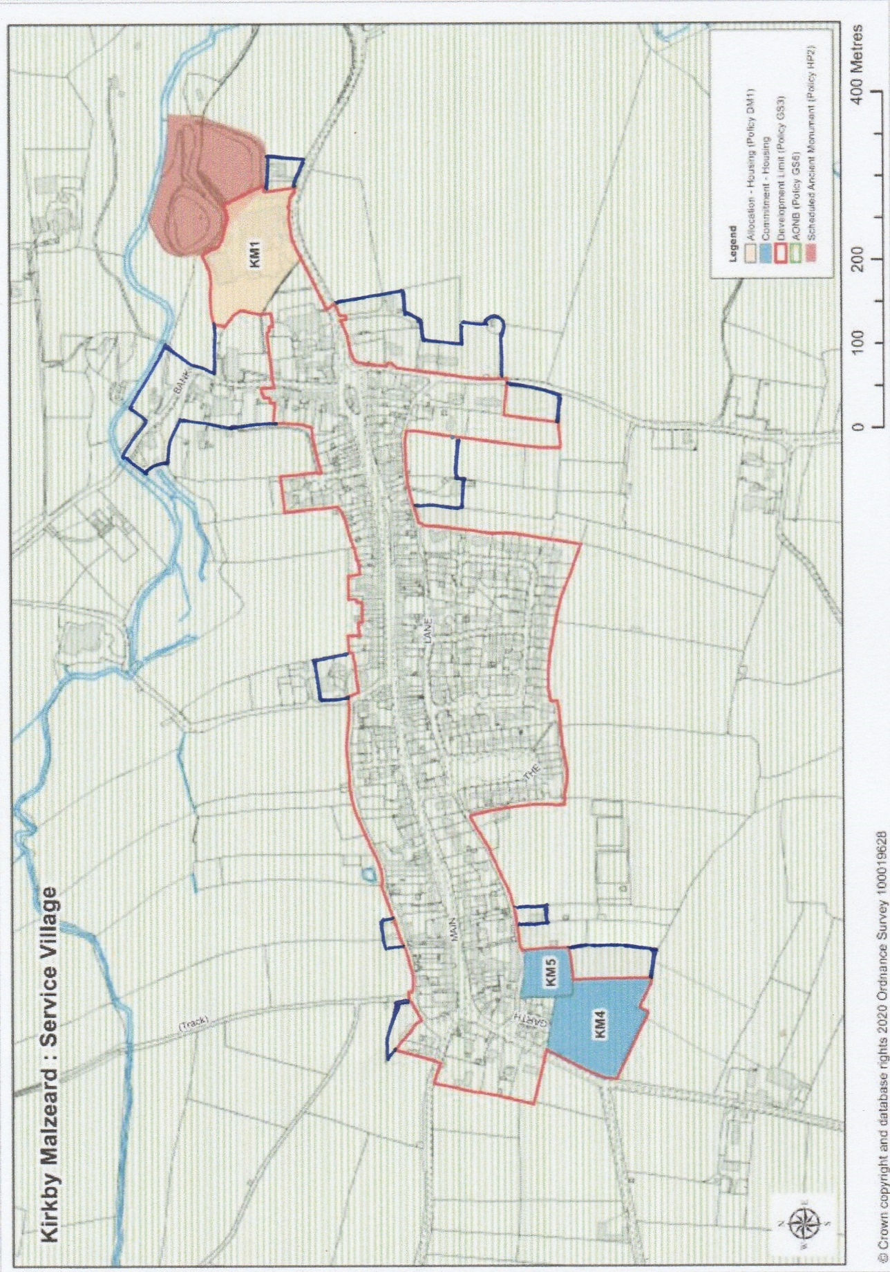

Kirkby Malzeard Development Limits Map showing existing (outlined in red) and with proposed additions (outlined in blue).

- Policy DM1 in the Local Plan identifies three housing sites in Kirkby Malzeard which will cater for the future housing needs for the parish and the wider Harrogate district. These three sites comprise the two existing housing ‘commitments’ - Land south of Richmond Garth (Local Plan Reference KM4) and Land east of Richmond Garth (Local Plan Reference KM5) with the potential to accommodate 37 dwellings over the two sites; and the new housing allocation – Wensleydale Dairy Products Limited (now trading as Saputo) (Local Plan Reference KM1) with the potential to accommodate 16 dwellings. Planning consent has subsequently been approved for the two housing commitments above for the provision of 33 homes (Ref 20/04874/REMMAJ). The location of these sites are shown in the Development Limits map above.

- Outside Kirkby Malzeard, as defined by the development limit boundary, the Local Plan does not make any housing allocations. It is essentially considered as open countryside in planning terms where there is strict control over development. As the Local Plan states in para 3.23 ‘Any land and buildings outside the defined limit will generally be considered countryside where there is a stricter control over development ‘. Adding, at Policy GS3, ‘proposals for new development will only be supported where expressly permitted by other policies of this plan or a neighbourhood plan or national planning policy’.

- The consultation shows that the community is generally comfortable with the amount and location of housing growth envisaged for the parish as set out in the Local Plan. When asked in the community questionnaire ‘Do you feel that more housing than that already allocated might be needed before 2035 both to meet future demand and help sustain facilities?’, less than a quarter (24.6% or 103) of the 412 respondents said yes.

- The community is clear, however, that it does not support any further housing development beyond that catered for in the Local Plan. This reflects and supports the view within the Local Plan which considers that the parish is not a suitable nor sustainable location for significant housing growth and that there are more sustainable locations for major development elsewhere in Harrogate district and further afield.

- The community also felt that the provision of additional infrastructure especially in terms of roads, parking, drainage (both sewer and surface water) is necessary as a result of planned new developments, and this should be addressed at the earliest opportunity.

Windfall Sites

- Windfall sites are sites not specifically identified for development in a local plan, neighbourhood plan or other development plan document. They mainly comprise redundant or underutilised buildings, including former farm buildings, or a small gap within an existing frontage of buildings. Usually, they are small sites suitable for only a single dwelling but could be larger. Normally windfall development is for new housing, though, in principle, could comprise other forms of development such as shops, employment units or community facilities.

- In recent years, the parish has already experienced significant windfall development, much of it housing related. This is a trend that is expected to continue. Though these sites cannot be identified in advance, the high degree of market pressure for new and other forms of development coupled with the level of vacant and underutilised land and buildings, including some which are agricultural related, means that windfall sites will continue to provide an important source of new housing.

- The consultation shows that the community is generally supportive of suitable small windfall development, especially the sympathetic conversion of historic farm building where this helps conserve and improve the character and appearance of the building better than any other use. There are several redundant farm buildings and more may come forward over the lifetime of the Plan. Given the limited opportunity for suitable housing sites across the parish, their reuse for residential purposes would be supported (where it can be shown that the building is no longer needed for agricultural purposes, where relevant).

- This is also in accordance with national and local planning policies that are generally supportive of the principle of windfall type development, especially within Kirkby Malzeard as defined by the Development Limit. Beyond Kirkby Malzeard while windfall development is permitted in principle there are stricter controls over it.

- It is important, however, that when windfall sites come forward, they are of high-quality design, suitable located and generally contribute to sustainable development. This is especially important as they will often be in isolated or sensitive locations.

- To ensure this, any such proposals must be considered in accordance with the policies in the Plan, as well as other supporting local and national planning policies.

Housing Mix

- Housing growth must help to meet the needs of all members of the local population. This is important for creating balanced and sustainable communities. This is of special significance for the Plan Area as there is some evidence that the housing type of the parish is unbalanced.

- Analysis of the 2011 Census results shows that there is a relative lack of smaller housing and a relative over provision of larger housing (analysis from the 2021 census is not yet available). At 34%, for example, the number of dwellings with four or more bedrooms is nearly double the national (18.9%) and regional (17.7%) averages and well above the Harrogate district average (27.2%). Furthermore, the evidence suggests that most of the new homes built in the parish in recent years have been larger homes. Land Registry data shows that between 1995 and 2007 the majority 59% of new build housing residential sales were detached dwellings (more recent data will be provided once available).

- A housing mix skewed to larger dwellings will arguably not meet the needs of the parish’s ageing population. At 29.2% (2021 census) about a quarter of the population was aged over 65; a figure which is much higher than the Harrogate district (23.4%), regional (19.0%) and national averages (18.6%).

- The findings from the consultation also show support for the provision of smaller homes in housing developments, in particular 2-3 bedroomed houses, of a type suitable for young people, as well as for older residents wishing to downsize but remain in the parish. When asked in the community survey ‘Which of the following property types should be prioritised within new developments? – tick all that you consider appropriate’; the most popular option, by a wide margin, was 2-3 bedroomed homes. 80.0% (or 333) of the 412 respondents stated that these should be prioritised within new developments. The next most popular property type was 1 bedroomed homes/flats with 27.9% (or 115) of respondents prioritising this.

- Other reports and studies have also highlighted the need for smaller homes. Special mention here should be made of the Housing and Economic Development Needs Assessment 2018 (HEDNA), which was prepared by the Local Planning Authority. This, amongst other things, estimated the future need for different sizes of market housing in the district. It identifies that for both market and affordable housing there is a need for a mix of house sizes across the district with a focus on 2 bedroomed properties. This is reflected in the following statement which can be found in the Key Points Section ‘Based on the economic led forecasts there is a clear need across the district for market delivery to be focussed on 2 and 3 bedrooms. This reflects the aging population, existing stock and the need to support down-sizing’ (p.121).

- It recommends the following housing mix to meet the needs of residents of the district over the Plan period and these are reflected in the Local Plan.

 | 1-bed | 2-bed | 3-bed
Market housing | 0-5% | 30-35% | 40-45%
Affordable housing | 30-35% | 40-45% | 15-20%

- The HEDNA also recommends that localised changes may be required to the district housing mix to reflect particular housing needs.

POLICY KMLD2: HOUSING MIX.
To meet the identified need for smaller homes, no more than 50% of new homes in a development of two or more dwellings should have 4 or more bedrooms.

Affordable Housing
- Affordability of housing both for sale and rent is a long-standing major concern. This is not only reflected in the findings of the consultation undertaken as part of the preparation of the Plan, but also consistently in other reports and studies.

- This is mainly a consequence of the above average house prices in the parish. In 2022, the average house price in Kirkby Malzeard was £495,865 compared to £341,628 in the whole of the Ripon postcode area. This was significantly above the UK House Price Index figures for December 2022 for England (£310,116), North Yorkshire (£281,422) and over double the Yorkshire and Humber average of £210,690. A figure that is well beyond the means of many people who wish to live in the parish, especially those on low or modest incomes or those trying to enter the property market, including those who have been brought up and wish to remain here. Furthermore, at 7.1% the proportion of housing in the parish which is ‘socially rented’ is far below the Harrogate (9.9%), Yorkshire and Humber (17.3%) and England (17.1%) averages, according to the 2021 Census.

- The Local Planning Authority sets out the detailed policies concerning the provision of affordable housing. These include target levels of affordable homes to be provided in new housing developments. Policy HS2: Affordable Housing in the Local Plan requires, amongst other things, ‘40% affordable housing on all qualifying greenfield developments including mixed use schemes, and 30% on all qualifying brownfield developments including mixed use schemes and conversions, subject to viability and the demonstration of the need for affordable housing’. Adding, ‘The final tenure mix of the affordable housing on individual sites will be determined through negotiation taking account of up-to-date assessments and the characteristics of the area’.

- Seventeen new affordable houses are required to be provided as part of the Housing Allocation (KM 1 -Saputo/Wensleydale Dairy Products Limited) and the two existing housing ‘commitments’ (KM4 and KM 5 - Land south of Richmond Garth and Land east of Richmond Garth), in accordance with Local Plan Policy HS2. This should provide a useful boost to affordable housing provision in the parish if these developments ultimately take place.

- A ‘Local Lettings’ policy had been suggested as a possible mechanism that may help address the affordable housing challenges in the Parish. Such a policy could mean that priority for affordable housing on all new eligible housing developments in the Plan Area would be given to people from this Parish only.

The ‘Local Connection’ policy currently being implemented by the Local Authority for this Parish is based on a group of Parishes known as ‘Ripon West Villages’ which includes those surrounding Parishes set out in the paragraph below which is used within the s106 agreements drawn up with developers:

“Eligible Occupier” means a person or household containing a person who is in housing need for a property of the type in question and who is unable to afford to purchase or rent dwellings of a similar kind generally available on the open market within the administrative area of the Council provided that a person within the household has a Local Connection with the Ripon West Villages Sub Area comprising parishes of Aldfield, Azerley, Eavestone, Grantley, Grewelthorpe, Kirkby Malzeard, Laverton, Lindrick with Studley Royal and Fountains, North Stainley with Sleningford, Sawley, Skelding, Studley Roger and Winksley, but in the event that no such person or household seeks to occupy the Affordable Housing Unit then the Registered Provider may widen the Local Connection catchment to the District of the Council with the written approval of the Corporate Director of Community Development.
On reflection it is felt that as the Local Plan has not allocated any significant amount of new housing in the other Parishes with the Ripon West Villages, it would be unreasonable to exclude those people with a Local Connection there from being eligible for affordable housing here, and therefore this potential Policy will not be pursued within this Plan.

- Rural exception sites have been highlighted as possible mechanisms to provide more affordable housing in the parish to meet local need. The NPPF in its glossary of terms describes Rural exception sites as ‘Small sites used for affordable housing in perpetuity where sites would not normally be used for housing. Rural exception sites seek to address the needs of the local community by accommodating households who are either current residents or have an existing family or employment connection’. Adding that ‘A proportion of market homes may be allowed on the site at the local planning authority’s discretion, for example where essential to enable the delivery of affordable units without grant funding’. National and local planning policies are generally supportive of Rural Exception sites in special circumstances. Rural Exception sites have been used by many parish councils and others to provide affordable homes for local people. The Plan is supportive of, and actively encourages, a Rural Exception site and other forms of community-led housing where there is clearly identified local housing need which otherwise would not be met through the provisions of the Local Plan (especially Policy HS2) and which is in accordance with relevant local and national planning policies.

- It should also be noted consideration was given to introducing a policy in the Plan seeking to vary the target for affordable housing provision in new housing development contained in Local Plan Policy HS2. It is not considered that the evidence gathered could justify this. It does, however, underline the need and compelling case that local targets for affordable housing provision in the parish at the very least should be met and assertively applied. This Plan supports and reinforces Local Plan Policy HS2.

PARISH ACTION 1: AFFORDABLE HOUSING PROVISION.
The Parish Council will monitor the provision of affordable housing on the developments which have been ‘allocated’ or which are ‘commitments’ under the Local Plan. If these prove inadequate to meet the local housing need of the Parish, it will pursue a community-led housing scheme through the means of a Rural Exception site if appropriate.

Meeting the Essential Housing Needs of Rural Workers

- Meeting the essential housing needs of rural workers was a theme during the consultation. The parish is a relatively large rural parish, and agriculture is important to its distinctive character, well-being, and sustainable development. This issue is, therefore, of special significance to it.

- The NPPF states local planning authorities should avoid new isolated homes in the countryside unless there are special circumstances. One of these circumstances is where there is an essential need for a rural worker to live permanently at or near their place of work in the countryside. Local Plan Policy HS9 (Rural Workers Dwellings) set out the special circumstances where rural workers dwellings may be permitted in the countryside. This is a policy position that the Plan supports.

- However, it is important to ensure that where such Consents are granted, occupation is restricted to rural workers (with appropriate checks being carried out by the Authority as necessary) and also that applications to have the restrictions lifted are refused.

POLICY KMLD3: PROPERTIES WITH AGRICULTURAL OCCUPANCY RESTRICTIONS.
The Parish Council will not support any applications to remove the occupancy requirements of rural workers dwellings.

Conversion Of Redundant Agricultural Buildings

37. Modernisation of agricultural practices have led to some traditional farm buildings becoming redundant. The increased size of farm machinery often means that old barns, granaries and general storage buildings are no longer usable and the cost of continuing to maintain them cannot be justified.
38. They are however often important individual features within the landscape or as a cluster of buildings within a farmyard and rather than these falling into a state of dereliction and disrepair, alternative uses, whether of a residential or commercial nature, should be encouraged.

POLICY KMLD4: RE-USING REDUNDANT AGRICULTURAL BUILDINGS.
Where planning consent is required for the conversion of redundant traditional barns and other agricultural buildings to form residential units or business premises, such consent would be granted, providing that the new use does not detract from the landscape value of the area and conversion is undertaken in a manner which is sympathetic to surrounding properties.

Second Homes and Holiday Lets

39. Consultation responses indicated that there was some concern that the nature of the parish could be adversely affected if the percentage of residential properties which are not permanently occupied were to significantly increase in the future. At present most houses are owner-occupied or rented as a main permanent residence but, as in most rural areas, there are some which are used as holiday lets or solely as second homes.
40. Within this parish the number of properties available for short term holiday lets throughout the year (through Air BnB or traditional letting agencies) has grown over the last decade, but a similar increase of properties has not been seen for those which are used as ‘second homes’, which by definition are those which are used solely by the owners for their own occupation for brief periods during the year and which stand empty the remaining months.
41. The concerns are that the use of properties as holiday lets or second homes reduces the number of properties available for local people to buy or rent for their main home and that the owners of such properties do not support local facilities such as shops in the same way, if they are only being occupied for limited periods during the year.
42. There is a positive effect from there being some holiday lets available as these support tourism in the area and can provide short term accommodation in the closed season for people working here temporarily or are in the process of buying and selling homes.
43. The conclusion is that no Policies or Parish Actions are presently required to control the numbers of holiday lets or second homes as part of the current Plan but the matter will be specifically considered again when the Plan is next reviewed.

Source: Rightmove.co.uk using Land Registry data.

