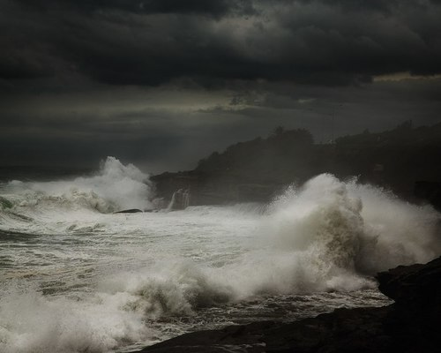
The Seahorse
by Patrice Lyth
At first, it’s not at all easy to make out what you can see, as you gaze wistfully out at the grey windswept morning that greets you through the upstairs window. Billowing trees, dancing with unseen partners; the colours of the garden heightened by the tell-tale signs of a passing shower; somewhere out there, though hidden from view, the restless tide creeps greedily up the pebbled shore, more persistently today with the wild weather.
The next bit of the morning ritual unfurls as you descend to the dim hall, and reach for the waterproof coat and trousers hanging by the door. Then, safely disguised, you venture out, a sideways gust of wind stealing a breath and sending you briefly in the wrong direction.
These early morning walks have become a habit now, but the first surprise has been that each day has its own unique character. Despite taking the same familiar route, you notice differences, some subtle, playing games with memory, or others very much in your face, like the invigorating wind buffeting you this morning, persuading you to join in its wild antics.
Because the usual view is hidden for now, teasing you with odd glimpses of what you expect to see, you keep your head lowered away from the wind, scanning the ground before your feet reach it, taking in the mottled patterns made by the ever-present moss, the unique shape of each stone and the prints of creatures passing there earlier, remembered in the mud. Then, before you know it, the top of the path to the beach looms into view, and your way becomes increasingly uneven, testing your balance in the insistent wind and rain.
Usually by now, you have heard a myriad of birdsong, but today the weather has put paid to that, and you are aware of the crashing waves well before you see them. Your only companions clambering down through the rocks, are rivulets of water trickling excitedly shore-wards, before gleefully becoming one with the receding tide as it gets ready for the next onslaught of the hapless sand.
And then you see it – it’s so unexpected that you have to look away, then back again, as your mind tells you that you are mistaken, and conjures up sensible explanations to help it relax, and quieten your quickening heart. Because it’s never still, it gradually reveals itself in tantalisingly brief impressions of shape and movement, piecing together something familiar yet previously unseen, a complete and utterly joyful surprise. You feel embarrassed, as if you have happened upon someone’s private and intimate moments, unaware that they are being watched, so you freeze, hardly daring to breathe, but you can’t disentangle your eyes from what you are witnessing.
It races enthusiastically and energetically towards the shore, surrounded by translucent foam and froth that flings itself unchecked and thrilled, into the mottled grey sky. Half-buried in spray, it’s legs are unseen, as it gallops rolling and pitching in the white, ever forward, frolicking in its delight to be there. And then, beckoned back unrelentingly by the simmering ocean, it reluctantly reverses to whence it came, as if being dragged by hidden arms reaching up from the seabed.
Mesmerised, you watch for what seems like hours, unwilling to be torn from such a spectacle. But you feel a sudden subtle change enfolding the scene, stealing a quick glance over your shoulder to unmask it, unwittingly breaking the spell.
When you look back, the sea horse has left.
April 2020

